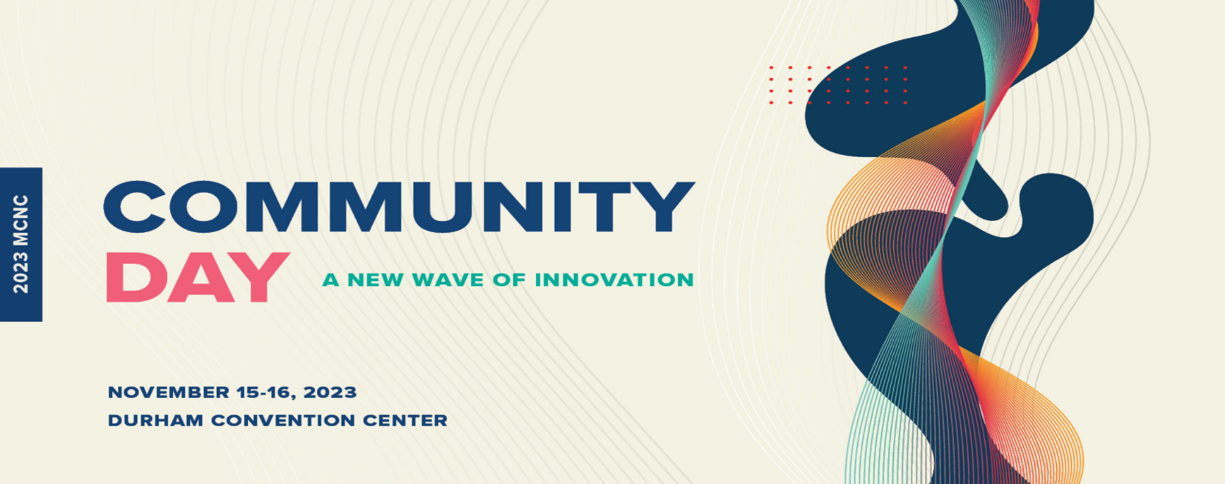
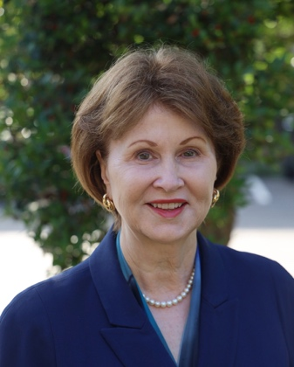
Dr. A. Hope Williams
Director of Software Engineering for Cloud Networking
Google

Dr. A. Hope Williams is president of North Carolina Independent Colleges and Universities, NCICU, the statewide advocacy and public policy organization of the 36 independent (private, non-profit) colleges and universities in the state and which raises corporate and foundation funds for student scholarships and programs. She has been president of NCICU since 1992.
Dr. Williams serves on the Governor’s Education Cabinet, is Presiding Officer for State Funds Network of the Council of Independent Colleges and has served as chair of the National Association of Independent Colleges and Universities State Executives and as a member of the board of the National Association of Independent Colleges and Universities.
She received her undergraduate degree from Duke University, a master’s degree from North Carolina State University and a doctorate in Education from the University of North Carolina at Chapel Hill. She was named the 1999 Distinguished Woman of North Carolina in Education, one of the top 25 Women in Business in 2001 by The Business Journal, a Woman Extraordinaire in 2005 by Business Leader Magazine and a Woman of Achievement by the General Federation of Women’s Clubs in North Carolina in 2007.
She has served as president of the North Carolina Adult Education Association and of the North Carolina Association of Institutional Researchers. She serves on the boards of the College Foundation, Incorporated; MCNC; and on the National Advisory Board of the Institute for Emerging Issues. She and her husband, Tom Bersuder, are the parents of two sons.

