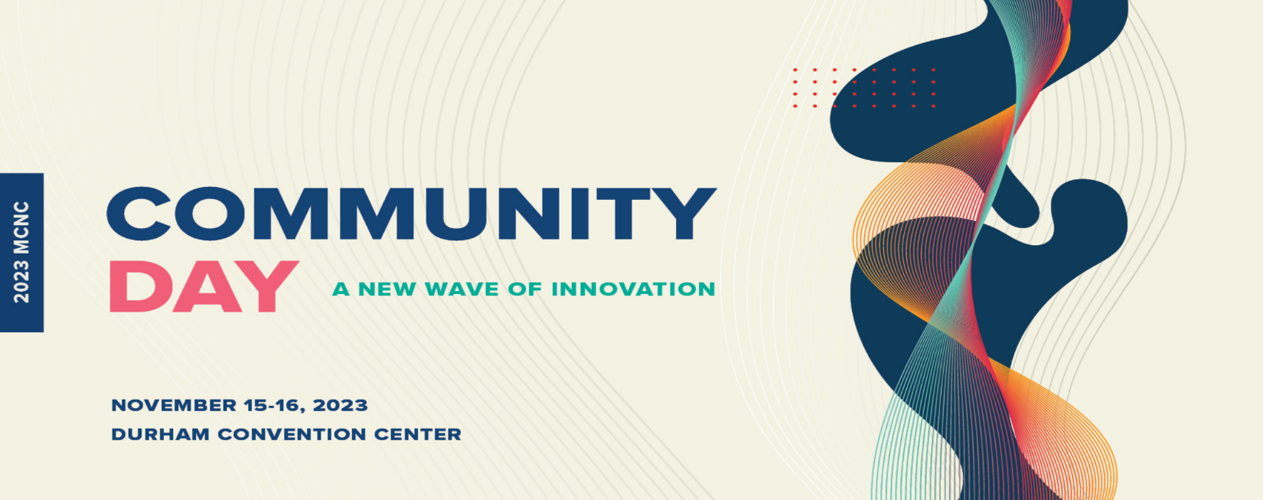
Jason Ward
Professor, Department of Biological and Agricultural Engineering
North Carolina State University

Jason Ward is an assistant professor and Extension specialist in the Department of Biological and Agricultural Engineering at NC State University where he leads the Advanced Ag Lab. His research and Extension program focus on advancing agricultural technology, sensors, machinery systems, automation, and data management. His goal is making precision agriculture technologies more accessible and valuable.

