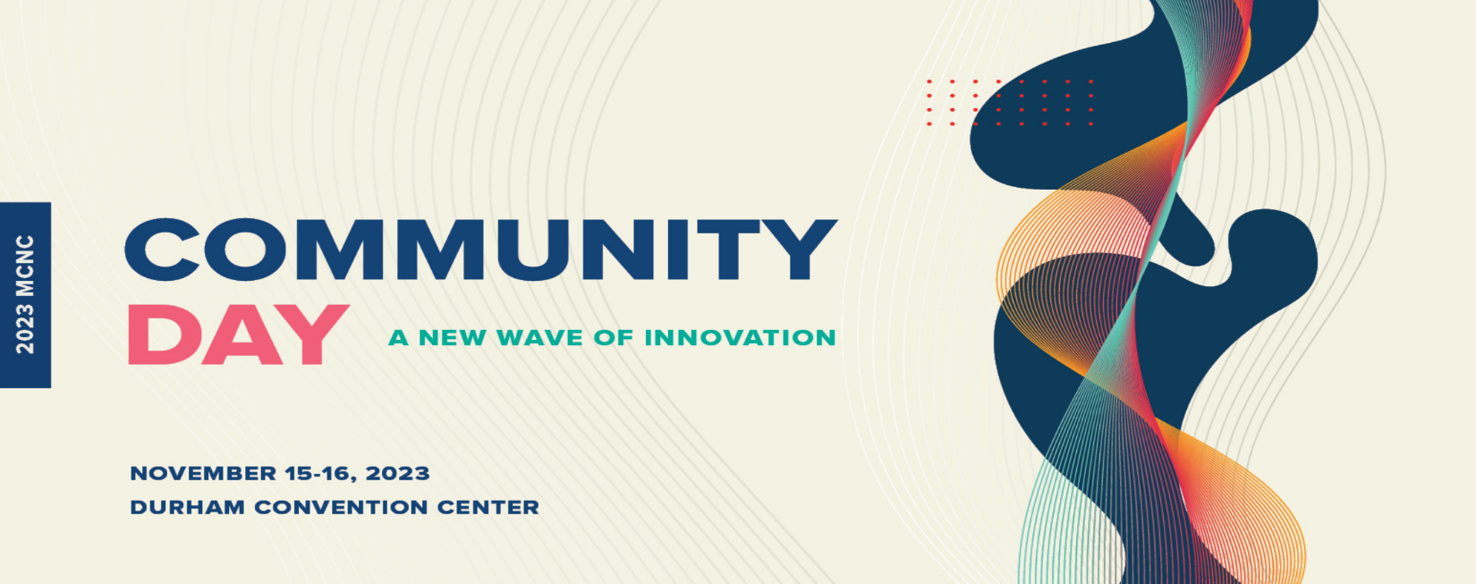
Branislav Vlahovic
Professor, Director of CREST and NASA Research Centers, Centers for Research Excellence in Science and Technology
North Carolina Central University (NCCU)
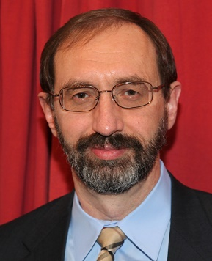
Branislav Vlahovic is a professor of physics in the Department of Mathematics and Physics and the director of the Computational National Science Foundation (NSF) Center of Research Excellence, National Aeronautics and Space Administration (NASA) University Research Center for Aerospace Devices, and the Department of Homeland Security Center for Detectors at NCCU.

He was awarded the Oliver Max Gardner Award, the only statewide recognition from the University of North Carolina system, for his significant research contributions and outstanding work with students. His extensive research comprising over 400 peer-reviewed publications, covers a broad range of disciplines, including experimental and theoretical nuclear and hypernuclear physics, material science, nanotechnology, quantum computing, photonics and photovoltaics, chemistry, cosmology, genomics and mathematics. He is also a member of the European Academy of Sciences and Arts.

