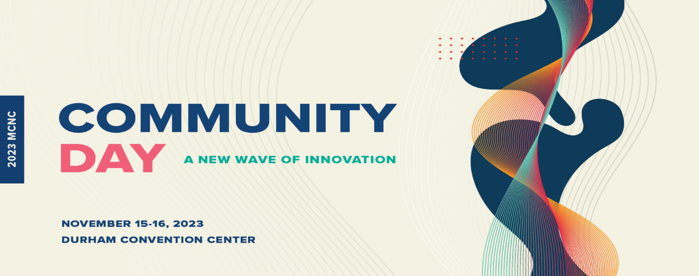
Ed Turlington
Partner
Brooks Pierce

Ed Turlington is a partner at the Brooks Pierce law firm, which has 110 lawyers with offices in Raleigh, Greensboro, and Wilmington.

His law practice includes representing clients before the executive branch, legislative branch, and agencies on a variety of matters. This includes work on procurement and contract matters with state agencies including the Department of Information Technology. He has been ranked by the North Carolina Center for Public Policy Research in the top three percent of all registered lobbyists in the state.

Ed’s record of public service includes serving as Chief of Staff to both the Governor and Lt. Governor of North Carolina, as Special Assistant/Counsel to a United States Senator, and as a national advisor to three presidential candidates.

He holds an undergraduate degree from Duke University and a law degree from UNC-Chapel Hill.

