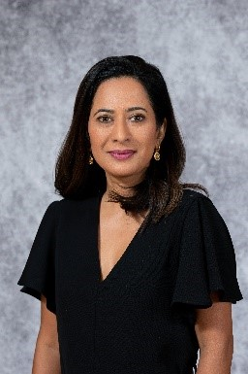
Dr. Kamala Subramaniam
Director of Software Engineering for Cloud Networking
Google

Kamala Subramaniam is the Director of Software Engineering for Cloud Networking at Google. Kamala also serves as the Google Engineering Site Lead for the Durham, North Carolina office and is responsible for growing Google Cloud’s presence in North Carolina and building an ecosystem of academia, the industry, and the local communities. Kamala will focus on research, scientific discovery, and technological advancement, all with a keen focus on diversity and inclusion. Kamala is also the Diversity & Inclusion leader for Google Networking, passionate about hiring and growing underrepresented talent in her organizations. She received both an MS and a Phd in Computer Engineering from North Carolina State University (NCSU). Kamala serves on NCSU’s Computer Science Strategic Advisory Board and is a member of NCSU's Board of Visitors.

