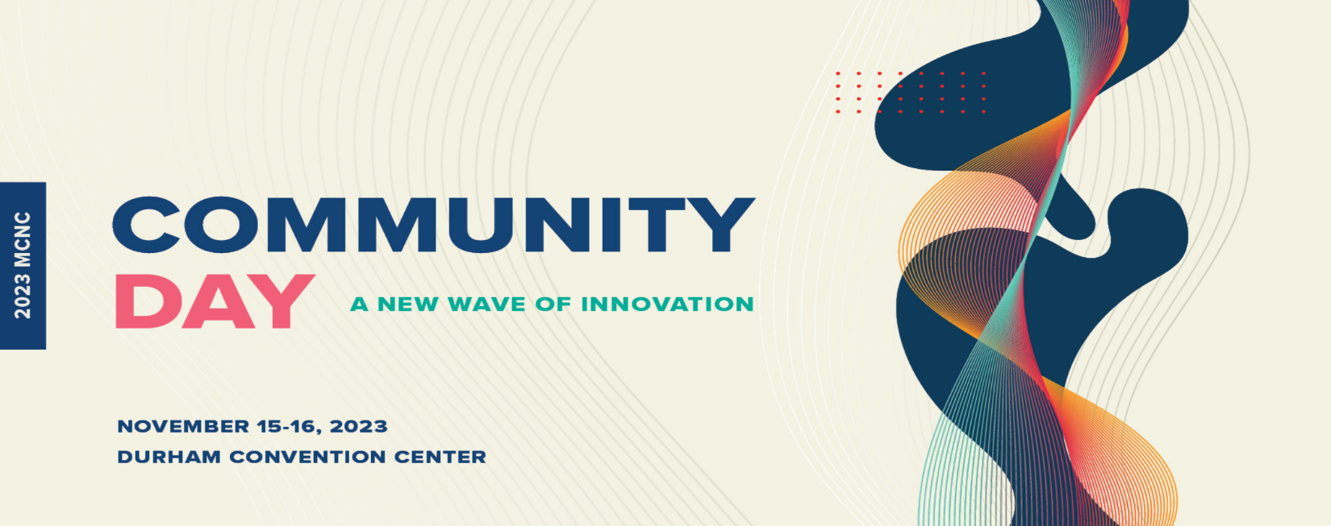
Daniel Stancil
Alcoa Distinguised Professor & Head, Department of Electrical and Computer Engineering, North Carolina State University
Executive Director, IBM Quantum Hub

Daniel D. Stancil is the Alcoa Distinguished Professor and Executive Director of the IBM Quantum Innovation Center at NC State. His early interest in radios and electronics launched an engineering career that has been--and continues to be--fun and rewarding. Along the way he picked up engineering degrees from Tennessee Tech (B.S.E.E.) and MIT (M.S., E.E. and Ph.D.). He has spent many years as a professor of Electrical and Computer Engineering at both Carnegie Mellon University and NC State. While at CMU he served as Associate Head of the ECE Department, and Associate Dean for Academic Affairs in the College of Engineering. He was Head of the Electrical and Computer Engineering Department at North Carolina State University from 2009-2023.

His research has included such varied topics as magnetic films, optics, microwaves, wireless channels, antennas, remote labs, and particle physics. Technology for distributing wireless signals through HVAC ducts that Dr. Stancil and his students developed has been installed in such major buildings as Chicago's Trump Towers and McCormick Place Convention Center. The demonstration of neutrino communications by a multidisciplinary team coordinated by Dr. Stancil was recognized by Physics World Magazine as one of the top 10 Physics Breakthroughs of 2012. Additional recognitions that his work has received have included an IR 100 Award and a Photonics Circle of Excellence Award. Dr. Stancil is a Fellow of the Institute of Electrical and Electronics Engineers and has served as president of the IEEE Magnetics Society as well as the ECE Department Heads Association.

