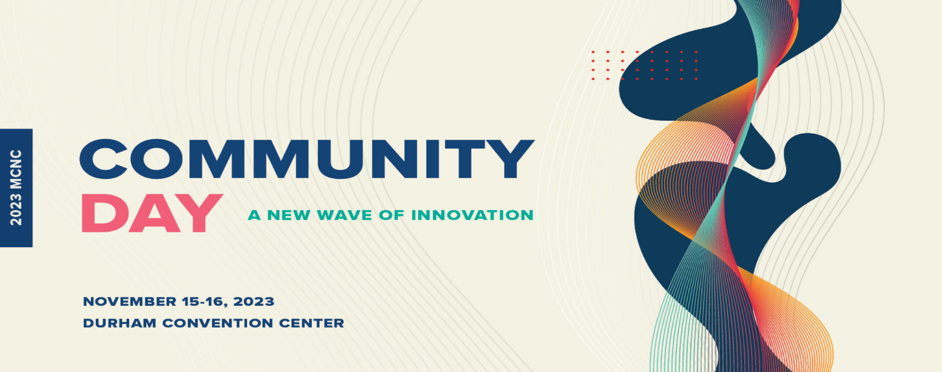
Dr. Marc Hoit
Vice Chancellor for Information Technology and CIO
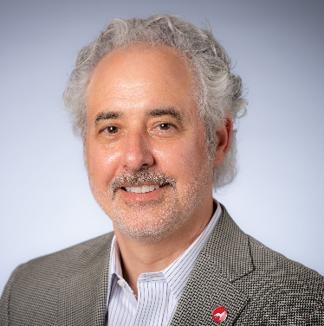
North Carolina State University

Dr. Marc Hoit is the Vice Chancellor for Information Technology and CIO at NC State University. Since arriving in 2008, he has led the development of a campus wide IT Strategic Plan, an IT Governance Structure and a Strategic Operating Plan and a number of key foundational projects that improved efficiency and effectiveness of IT. Hoit held numerous administrative positions at the University of Florida including Interim CIO, Director of Student PeopleSoft Implementation, Associate Dean for Academic Affairs Administration and Associate Dean for Research in the College of Engineering. He is a Professor of Structural Engineering in the Civil, Construction and Environmental Engineering Department at NC State. Hoit received his B.S. from Purdue University, M.S. and Ph.D. from University of California, Berkeley. Dr. Hoit was a Co-Principal Investigator for the Department of Homeland Security: NCB-Prepared Grant, with UNC Chapel Hill and SAS, which developed early warning systems for health security using big data. He was the PI for DIGGS, an international standard XML schema for transferring transportation information and data, funded by the Federal Highway Association. His structural engineering research developed the computer program, FB-MultiPier, which performs non-linear analysis of bridge piers, superstructure and pile foundations subjected to dynamic loading.

Dr. Hoit has been dedicating effort towards facilitation in supporting strategic plan development as well as training others to facilitate. His initial training was in 1995. Since then, he has lead the development of strategic plans for many engineering groups including the Everglades Restoration Project, American Society of Civil Engineers (ASCE) (in Publication, continuing education, leadership development and the Structures Congress), Infrastructure Advancement Institute (IAI), American Segmental Bridge Institute (ASBI), American Association of Environmental and Environmental Science Professors (AEESP). He and his training partner created the Facilitri.org organization to help in leadership development and train others to facilitate including IAI, Structural Engineering Institute (SEI) and others.

