Julius “Jay” Gamble
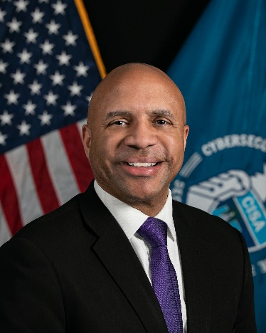
Regional Director for Region 4
Department of Homeland Security's Cybersecurity and Infrastructure Security Agency (CISA)

Julius “Jay” Gamble serves as the Regional Director for Region 4 of the Department of Homeland Security's Cybersecurity and Infrastructure Security Agency (CISA). In this role, he leads CISA’s efforts to reduce risk and enhance the cyber and physical resiliency of critical infrastructure throughout the eight southeastern states (AL, FL, GA, KY, MS, NC, SC and TN). He works with public sector partners, such as state, local, tribal, and territorial governments, as well as private-sector organizations essential to the nation’s homeland security.

Prior to joining CISA, he served as the assistant deputy chief of staff (G6) for the U.S. Army Forces Command (FORSCOM), where he provided leadership over the command’s IT and cybersecurity operations. He has also held previous leadership positions with DHS, the U.S. Customs and Border Protection and the city of Baltimore.

A strong advocate for students seeking cybersecurity careers within the federal government, Gamble has also served as an adjunct faculty member for the University of Maryland’s Global Campus Master of Science in Cybersecurity Technology Program since 2016.

Gamble earned a Master of Science Degree in Information Systems from the American University, a Master of Divinity Degree from The Howard University School of Divinity and a Bachelor of Science Degree in Business from Bowie State University. He holds several information technology industry certifications and is the recipient of several awards in recognition of his leadership, management, and technology contributions.

