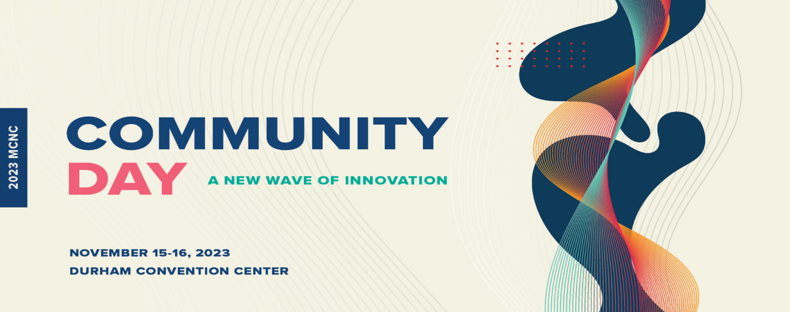
Patrick Fleming
Senior Vice President and Chief Information Officer
North Carolina Community College System Office

Patrick Fleming is Senior Vice President and Chief Information Officer for the North Carolina Community College System Office.

He is responsible for the delivery, operations, and maintenance of reliable, secure, and sustainable technology solutions designed to serve community college students, employers, and partners. As a transformational leader, Patrick works to unify people and processes with technology to drive the North Carolina Community College System forward. He is thankful to be a member of a strong Team who shares this vision and understands how collaboration, communication, and thoughtful decision-making improves outcomes.

Prior to joining the System Office Team in 2012, Patrick managed clinical and environmental laboratory information management systems for the North Carolina Department of Health and Human Services.
Patrick began his public service career with North Carolina in 2005 after a successful decade with a small, Raleigh based internet start-up and Microsoft partner named Clear and Vision Unlimited. Starting out as a network engineer in 1995, he specialized in voice-over-IP, internet services, and convincing small business owners to trade in their IBM Selectic II typewriters for desktop computers.

Patrick graduated from Appalachian State University with a Bachelor’s in History and earned his Master’s in History at East Carolina University. He is an avid SCUBA diver who enjoys leading other divers on underwater explorations at home and abroad.

