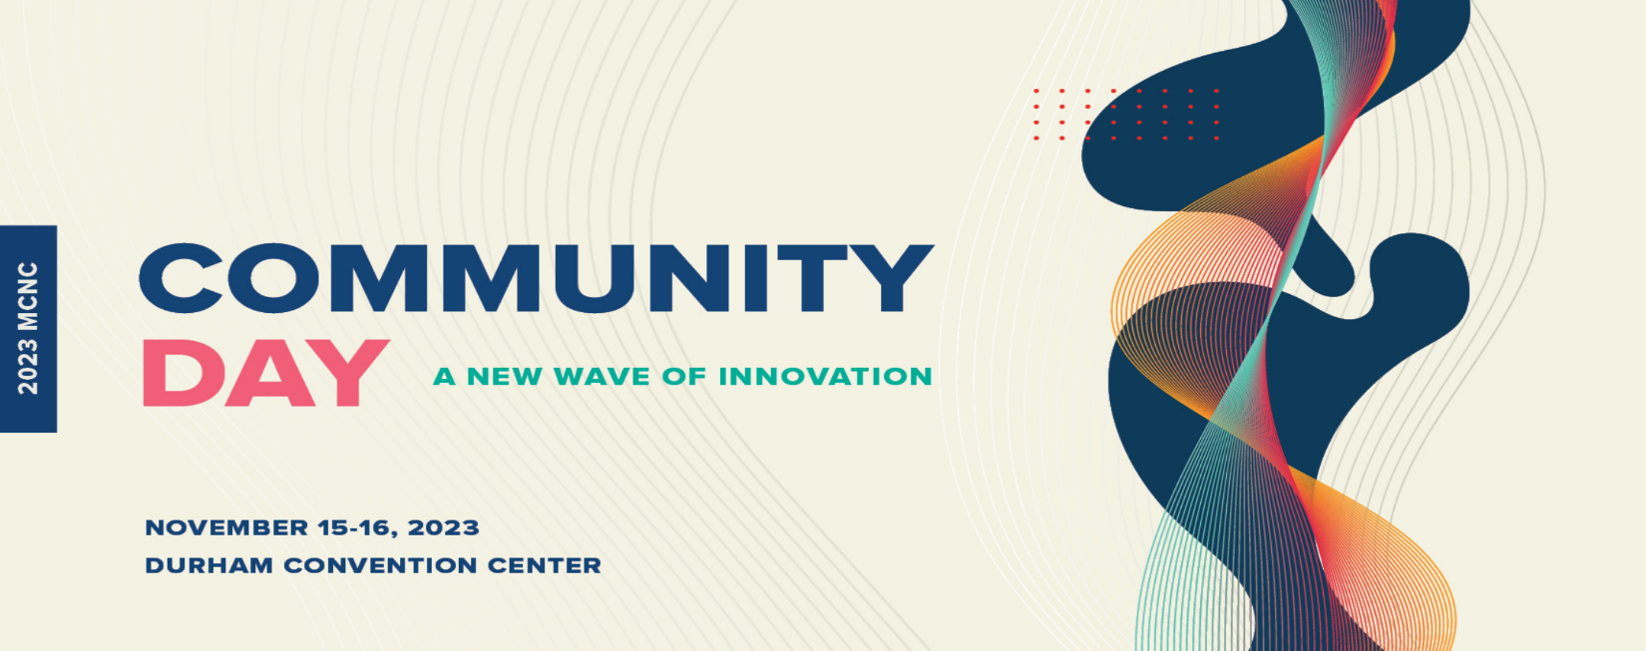
Debra Derr
Director, Government Affairs
NC Chamber

In Debra Derr’s role as director of government affairs, she assists the NC Chamber in programs that promote the mission and vision of the organization. As a content expert, she directs effective advocacy strategies in education, workforce development, manufacturing, and unemployment insurance issues.

Debra values the professional community and village atmosphere of the NC Chamber. She likes the variety of responsibilities her work provides as well as the opportunities leadership gives to succeed and fail with hope that each occasion brings growth and determination.

She often reflects on her favorite quote by Jim Rohn, “Never wish life were easier, wish that you were better.”

