Bo Coughlin
Chief Operating Officer
Fybe
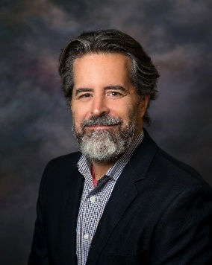
As COO of Fybe, Mr. Coughlin works with the board and senior leaders to direct management, strategy, and overall execution for the telecommunications company. Fybe is a wholly owned subsidiary of Roanoke Cooperative, located in rural northeast North Carolina, and is deploying over 4,000 miles of fiber optics to provide dependable fiber to the premise service to the communities served by the cooperative and beyond.

Most recently, Mr. Coughlin was the EVP/CTO at Knight Enterprises, a full service OSP/Utility Construction, Fulfillment and Information Technology Services firm with customers throughout the United States. Mr. Coughlin helped lead strategy and direct management of a portfolio of expanding businesses in the cable/telecommunications, information technology, and software industries. Mr. Coughlin played a critical role in the growth of the business - from $35M to over $120M in under 5 years - and the sale of Knight Enterprises to a Private Equity Firm in 2021.

Previously, Mr. Coughlin founded Rekindl a SaaS/PaaS geospatial/marketing analytics platform which was sold in 2014. Prior to Rekindl, Mr. Coughlin held various senior executive positions with Time Warner Cable while leading the company's broadband efforts, including President of the Carolina Region Business Services.

