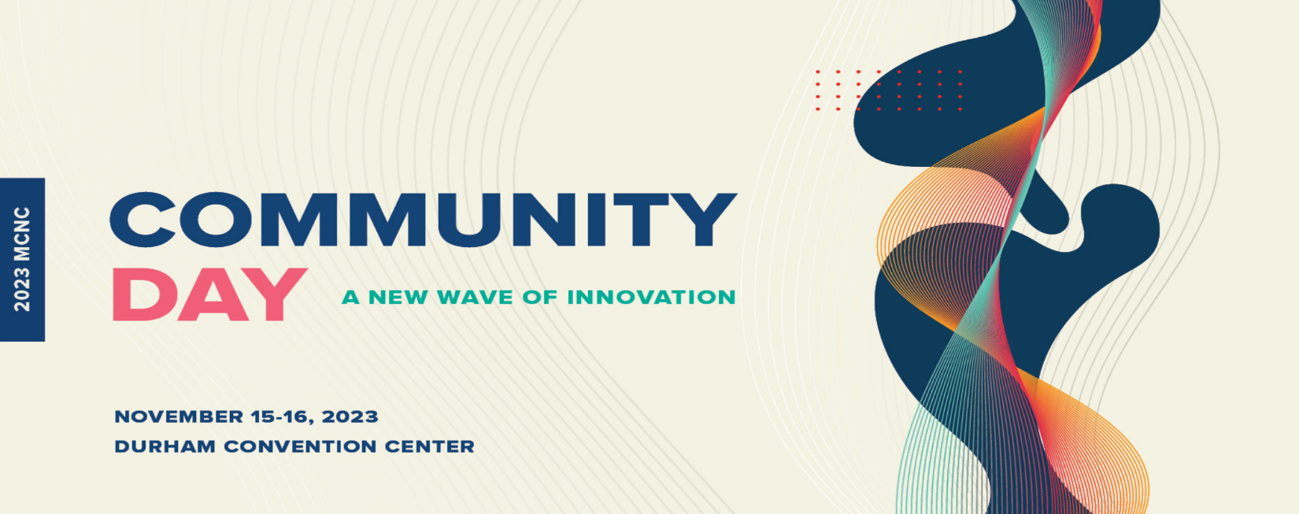
Anne Bacon
Director, Workforce Continuing Education
North Carolina Community College System Office
Anne Bacon is the Director of Workforce Continuing Education with the North Carolina Community College System. She works with community colleges, industry associations, and workforce development partners to build talent pipelines involving short-term training.
She has a Bachelor’s degree from the University of Virginia and a Master’s degree in Public Policy from Duke’s Sanford School of Public Policy.
Anne has worked on workforce development, economic development, and education issues for the State of North Carolina and the North Carolina Rural Center for more than 25 years. Outside of work, she volunteers for the Wake County Public School System, including as Business Alliance Chair for South Garner High School.

