Matt Valenzisi
Director of Network Architecture
MCNC

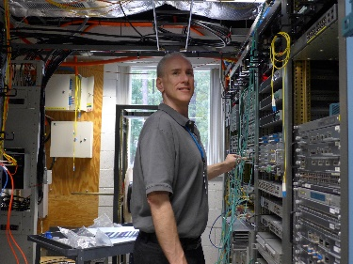
Matt Valenzisi has been with MCNC for 14 and a half years and currently serves as the Director of Network Architecture and Management as well as the Chief Network Architect for NCREN. He was previously the Lead Network Architect at NC State University where he spent 5 plus years and has held numerous Senior and/or Lead Network Engineering roles prior in a 25+ year career in the telecom industry.

