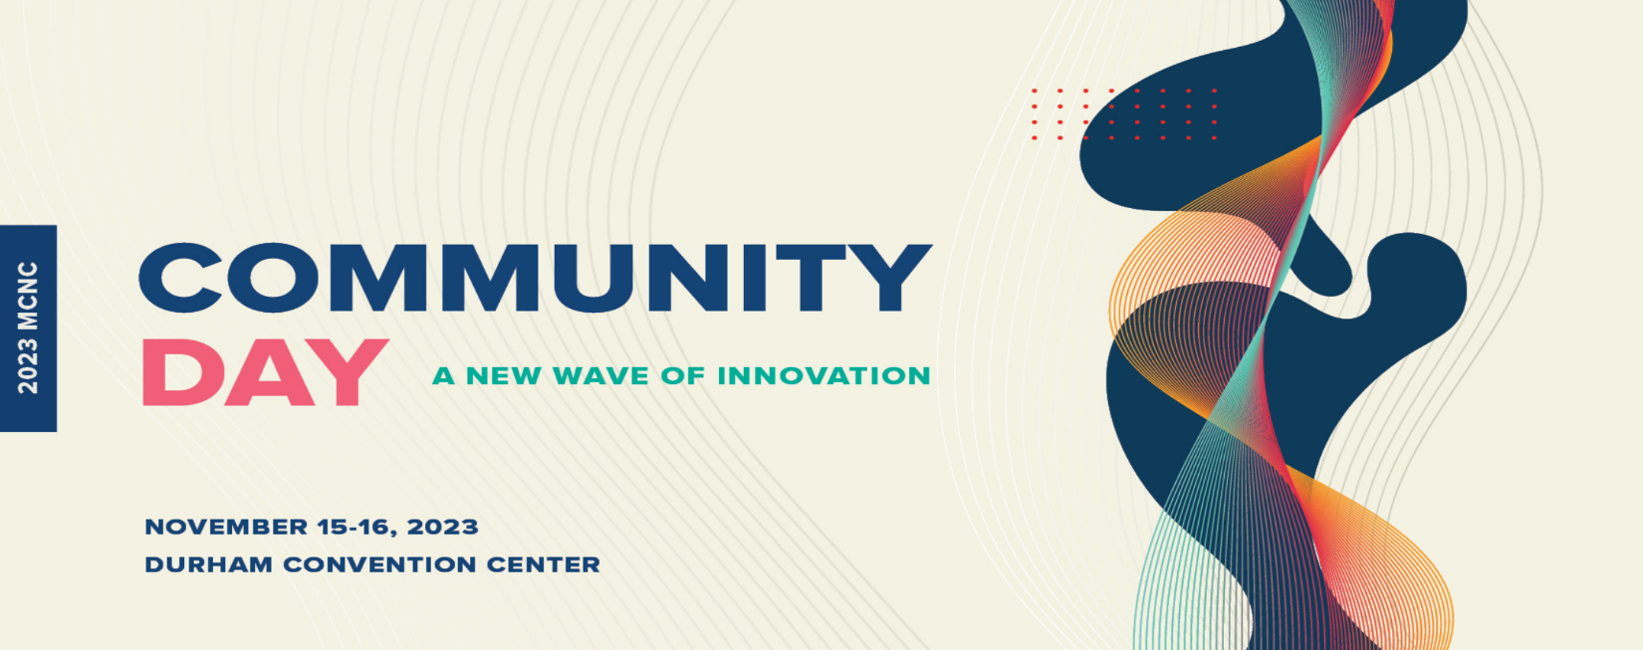
Maya Norvel
Community Affairs, Project Manager
Corning Incorporated
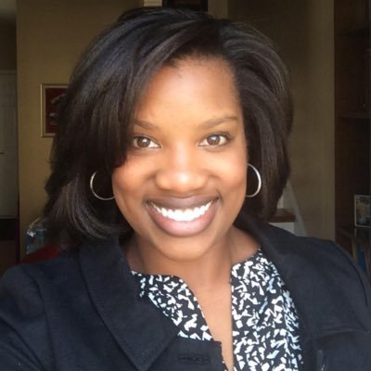
Maya has been a community affairs, project manager with Corning Incorporated for 2.5 years and is responsible for supporting global community affairs efforts with a focus on DEI and workforce development. She develops cross-functional teams, driving results, in support of multiple community initiatives. Most recently, Maya was the Communications and Community Engagement Manager with Charlotte Area Fund. She has over fifteen years of community outreach and engagement experience. Maya holds a bachelor’s in journalism and communications from Hampton University and currently serves on the Charlotte Digital Inclusion Alliance as
well as The NC Broadband Workforce Planning Advisory Committee.

