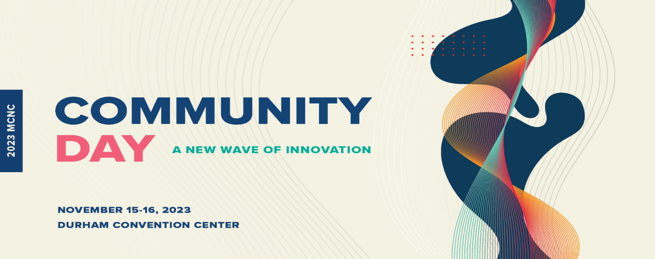
Dr. Wesley Moss
Fulbright Post Doctoral Scholar
North Carolina State University
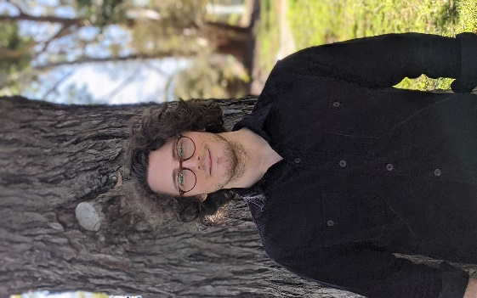
Dr. Wesley Moss is an engineer who is passionate about leveraging technology in agriculture to create a sustainable future. He is currently a visiting Fulbright researcher working with North Carolina State University and USDA Agricultural Research Service to investigate precision application technologies in farming. In 2024 Wesley returns to Australia to continue research at the University of Western Australia.

