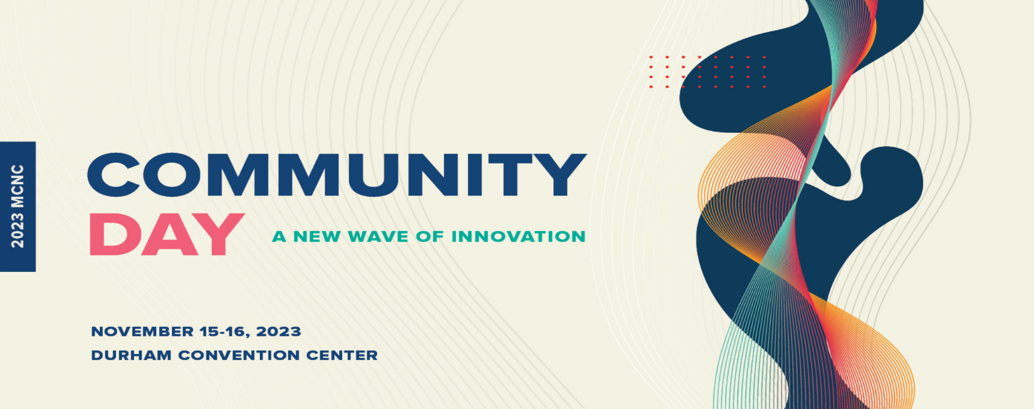
Dr. Gregory Goins
Associate Deam, Agricultural Research
Professor, Crop Science
North Carolina A&T State University

Dr. Gregory D. Goins serves as Associate Dean for Agricultural Research and as a Professor of Crop Science at North Carolina A&T State University. He is also the co-Director of the Small Farms Resource and Innovation Center (SFRIC) located within the tri-partite mission design of the College of Agriculture and Environmental Sciences (CAES). The SFRIC is an institutionalized space at NCA&T dedicated to small farms that integrates climate smart agricultural production, digital agriculture, heirs’ property retention, and agricultural entrepreneurship. In 2015 he was named as a White House Champion of Change for promoting student success at HBCUs. He served as a NSF Program Officer for the Noyce, IUSE, and S-STEM Programs in 2013-2014. He is the author of the 2010 4-H National Youth Science Experiment (the first-ever 4-H National Science Experiment to originate from an 1890 Land-Grant University).

