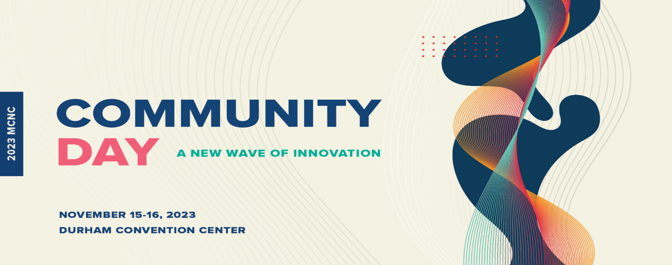
Mohammad Waseem Ahmed
Dean of the College of Health and Sciences
North Carolina Central University (NCCU)

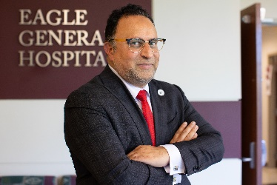
Mohammad Waseem Ahmed is the Dean of the College of Health and Sciences at the North Carolina Central University (NCCU). He serves as the chief academic officer and establishs the strategic vision and goals of the college, providing administrative oversight for all aspects of academic life within the college, including fiscal management, personnel professional development, academic programs, research enterprises and student enrollment. He also directs external initiatives that include community outreach and development and fundraising.

Ahmed earned a bachelor-of-science degree in Physics and a Ph.D. in Physics, both from the University of Houston. During his graduate work, Ahmed performed research at Los Alamos National Laboratory and Brookhaven National Laboratory (BNL) in nuclear physics. Subsequently, Ahmed joined the Triangle Universities Nuclear Laboratory (TUNL) on the campus of Duke University as a research scientist and continued as an assistant research professor of physics at Duke University until his arrival at NCCU in 2011.

Ahmed’s research interests include STEM education and experimental nuclear physics with focus on low-energy Quantum Chromodynamics. His scholarly activity includes topics in undergraduate education, particularly in STEM curriculum development. He has published more than 60 peer-reviewed articles and reviews, delivered more than 30 invited talks and mentored more than 30 students and post-docs. Ahmed has received grants totaling more than $4 million as a principal investigator from Department of Energy, National Science Foundation (NSF) and Department of Homeland Security during his time at NCCU.

He also serves as the Associate Director of Triangle Universities Nuclear Laboratory (TUNL), a consortium of Duke University, NCCU, NC State University and UNC Chapel Hill for experimental nuclear physics. Dr. Ahmed is also a fellow of Center for Advancement of STEM Leadership, a National Science Foundation funded project to bring leadership on HBCU campuses. He is a member of the American Physical Society (APS) with memberships in Division of Nuclear Physics (DNP) and Topical Group on Few-Body Physics. He has served as the chair of the Southeastern Section of the APS (SESAPS) as well as the chair of the North Carolina Science Fair Foundation Board of Directors.

